**Module-6: Assignment-2**

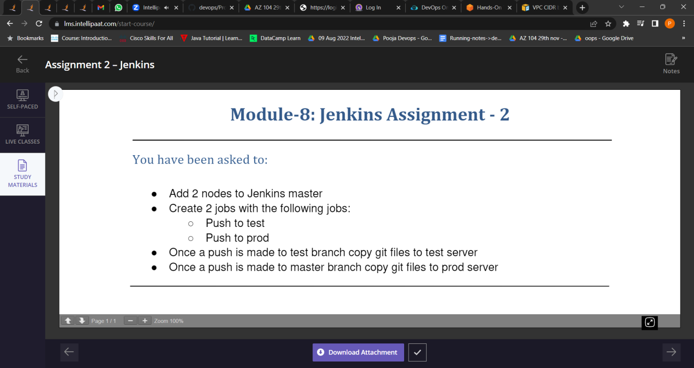

1. Add 2 nodes to Jenkins master.

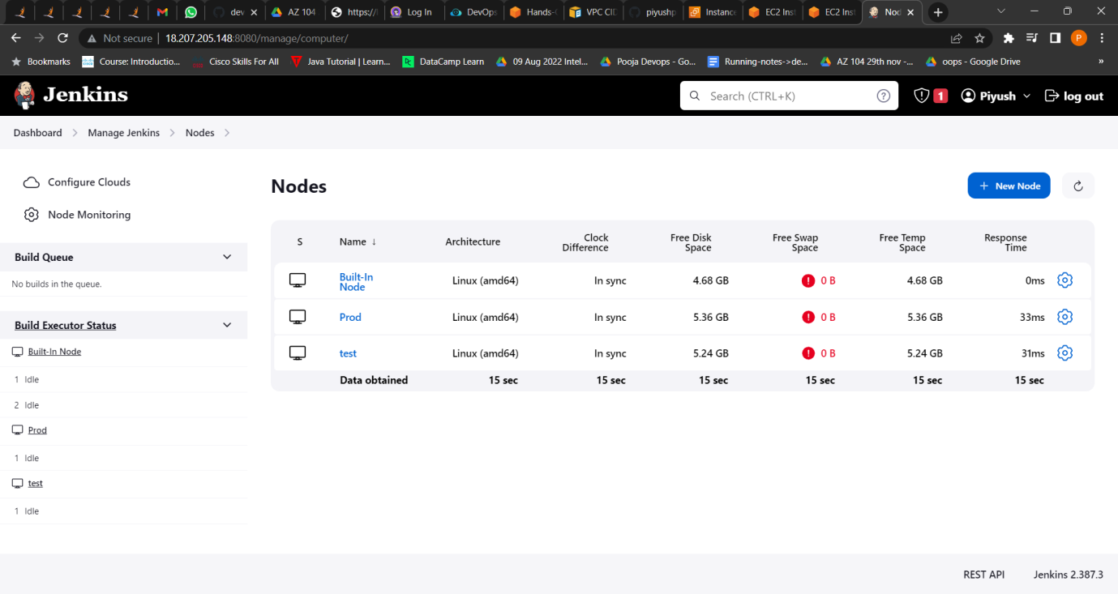

1. Created 2 jobs with the following jobs:

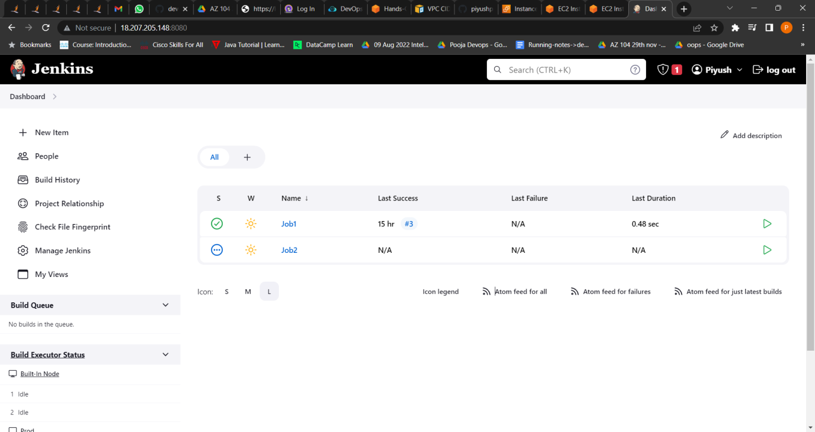

* 1. Push to test

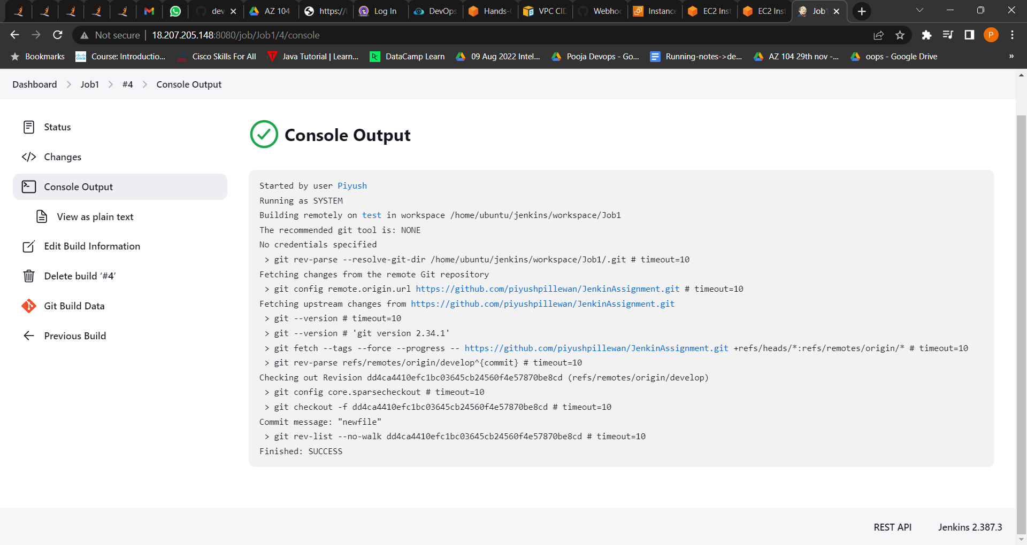

* 1. Push to prod

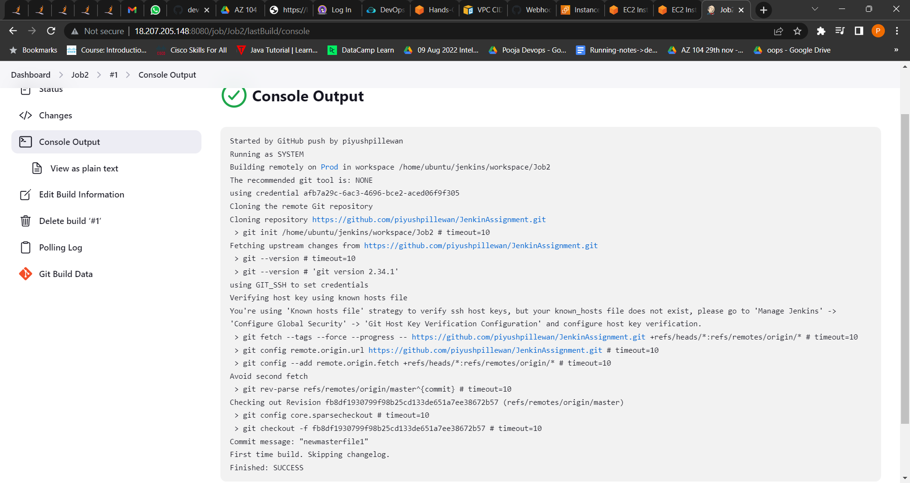

1. Once a push is made to test branch copy git files to test server.

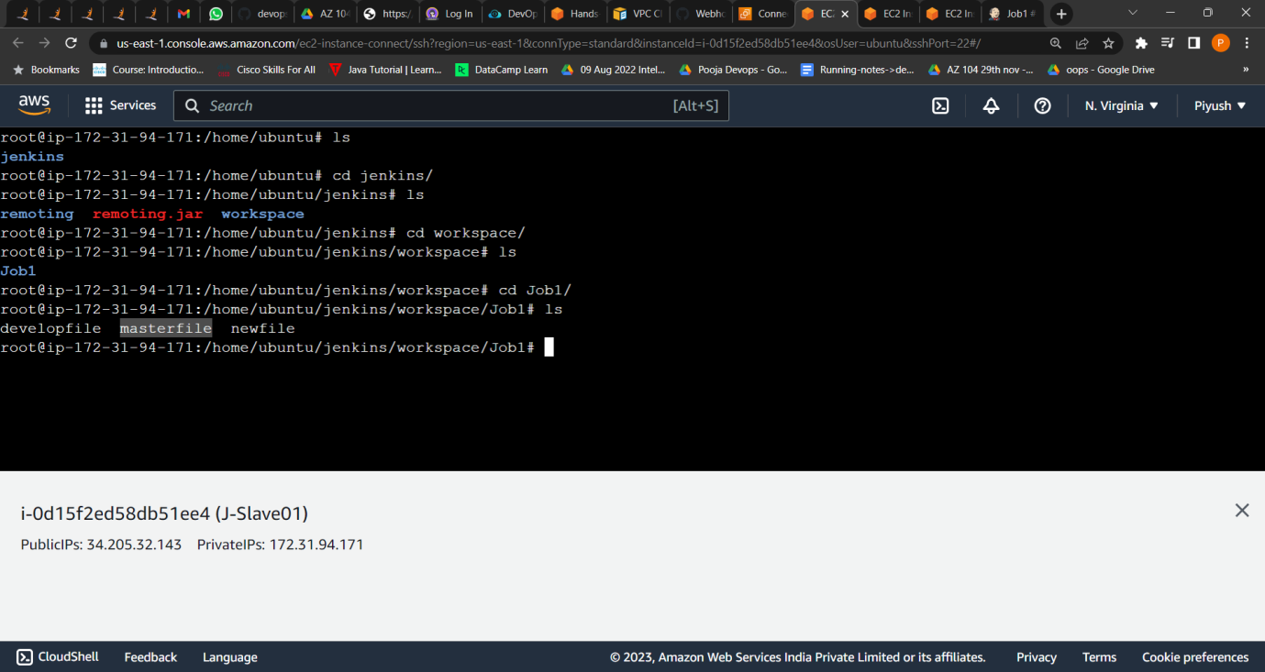

1. Once a push is made to master branch copy git files to prod server.



